Data Science is about working with data – Collection, Cleaning, Analyzing, Visualizing, Creating insights and Building ML models. DS often uses ML, statistics, SQL, Python.

Data Collection
Collecting information from various sources to answer specific questions or achieve a goal.
Types of Data Collection
- Primary Data Collection
- Surveys & Questionnaires
- Interviews
- Observations
- Focus Groups
- Experiments & A/B Testing - Comparing two or more versions of a product, website, or campaign to find the best-performing option.

- Secondary Data Collection
- Public Records & Government Data
- Industry Reports & Market Research Studies
- Academic & Scientific Research Papers
- Social Media & Web Analytics
- Business Databases & Third-Party Data Providers

Data cleaning / EDA (Exploratory Data Analysis) / Data Preprocessing
- Data Cleaning - Fix problems in data. Missing values, duplicates, wrong formats
Goal: make data usable
Steps:
- Load & Inspect: Import data (Pandas, NumPy) and check initial structure, data types, and shapes.
- Handle Missing Values: Identify (df.isnull().sum()), then impute (mean, median, mode) or remove.
- Remove Duplicates: Find and drop duplicate rows that skew results.
- Correct Inconsistencies: Standardize formats, units, and categories (e.g., 'USA' vs 'United States', age < 0, future dates).
- Address Outliers: Detect (box plots, Z-scores) and decide to cap, transform, or remove.

- Data Preprocessing - Prepare data for models. Encoding, scaling, feature engineering
Goal: make data model-ready
Steps:
- Feature Engineering: Create new features from existing ones (e.g., ratios, age groups).
- Feature Scaling: Standardize (Z-score) or Normalize (Min-Max) numerical data so features are on similar scales.
- Encode Categorical Data: Convert text categories to numbers (One-Hot Encoding, Label Encoding).
- Data Transformation: Apply functions (log, square root) to handle skewness.
- Dimensionality Reduction: Reduce the number of features (PCA) if needed.

- EDA (Exploratory Data Analysis) - Explore and understand data. Patterns, trends, relationships
Goal: gain insights and decide next steps
Steps:
- Check data shape and summary stats: df.shape, df.describe, df.info(), df[col].value_counts()
- Univariate Analysis: Analyze single variables (histograms for distribution, mean/median/mode).
- Bivariate/Multivariate Analysis: Explore relationships (scatter plots for two variables, correlation heatmaps).
- Visualize: Use plots (histograms, box plots, pair plots) to spot patterns, distributions, and outliers.

Data Visualization
Data visualization is the process of converting complex data into graphical formats such as charts, graphs, and maps.
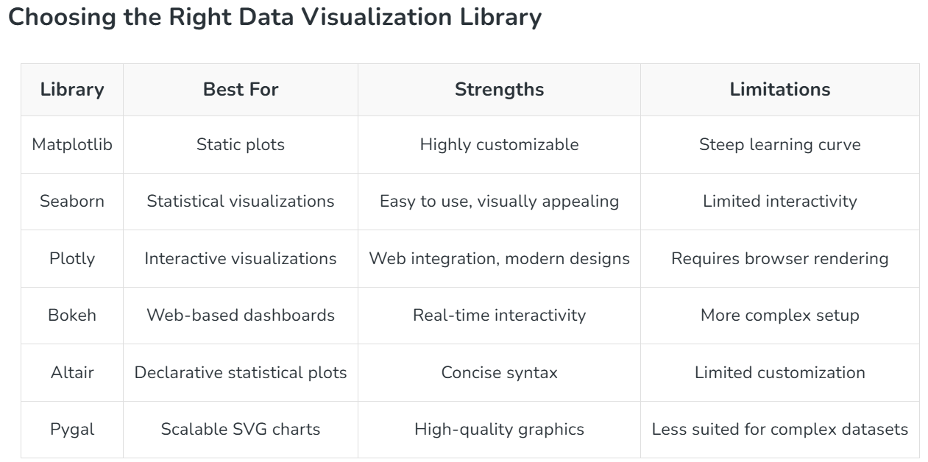
Common Types of Data Visualization
- Charts and Graphs: To identify correlations, trends and outliers. Examples: Bar Charts, Line Charts, Pie Charts, Scatter Plots, Histograms, Box Plots.
- Maps: Provides spatial context to trends and patterns. Examples: Geographic Maps, Heat Maps
- Dashboards: They combine multiple visualizations into a single interface which provides real-time insights and interactive features for users to explore data.

Basic Charts for Data Visualization
- Bar Charts
X-axis – categories, Y-axis - values. Include horizontal, stacked and grouped bar charts.
When to Use:
- To compare different categories
- To rank values from highest to lowest
- To show relationships between multiple variables

- Line Charts
Show how values change over time by connecting data points with lines. They help visualize trends like increases, decreases or stability.
When to Use:
- To track changes over time
- To compare trends across multiple data series
- For time series analysis

- Pie Charts
When to Use:
- To show how different parts contribute to a whole
- To highlight a dominant category

- Scatter Chart (Plots)
Show relationship between two numerical variables. X-axis - independent variable and Y-axis - dependent variable.
When to Use:
- To observe relationships between two variables
- To detect patterns, clusters or outliers in data

- Histogram
Distribution of numerical data by grouping values into intervals (bins) and showing their frequency as bars
When to Use:
- To visualize the distribution of numerical data
- To explore patterns, trends and outliers

Advanced Charts for Data Visualization
- Heatmap
When to Use:
- To identify clusters or groupings in data
- To visualize correlations between variables
- For risk analysis in fields like finance or network security

- Area Chart
When to Use:
- To track changes or trends over time
- To compare multiple data series
- To highlight patterns like seasonality or cycles

- Box Plot (Box-and-Whisker Plot)
When to Use:
- To detect outliers in data
- To compare distributions across groups
- To visualize spread and variability

- Bubble Chart
When to Use:
- To compare multiple variables at once
- To represent data using size and color
- To visualize relationships and detect patterns

- Tree Map
When to Use:
- To display hierarchical data
- To compare proportions within levels
- To visualize large datasets compactly

- Parallel Coordinates
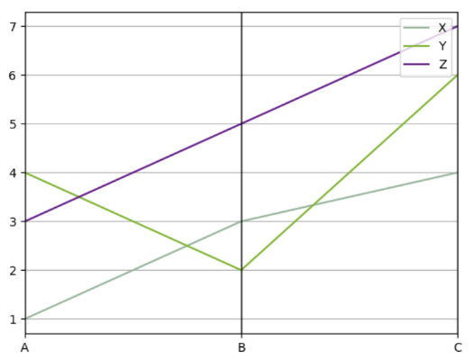
When to Use:
- To analyze multiple variables at once
- To visualize relationships or clusters
- To detect outliers in the data

- Choropleth Map
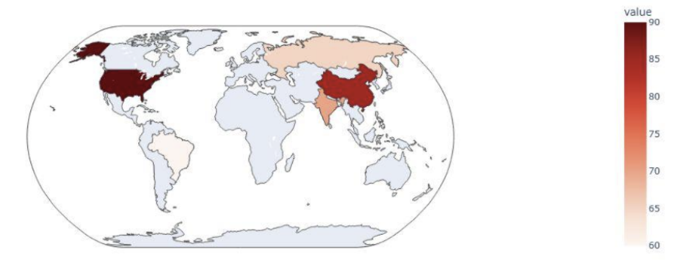
When to Use:
- To compare data across locations
- To spot geographic patterns and trends

- Sankey Diagram
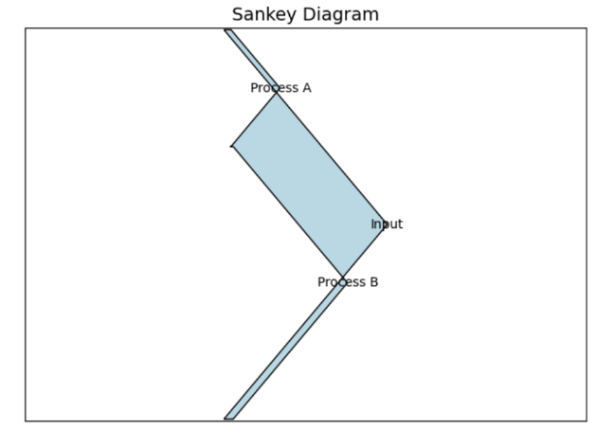
When to Use:
- Visualize Flows: Understand how resources move through a process.
- Find Bottlenecks: Identify points where flow slows or drops.
- Compare Scenarios: Track flow changes across time or conditions.

- Radar Chart (Spider Chart)
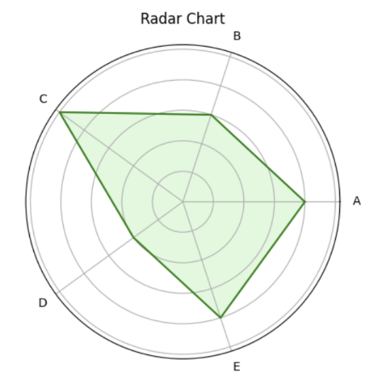
When to Use:
- Multi-Criteria Comparison: Compare multiple variables at once.
- Strengths & Weaknesses: Visualize strong and weak areas.
- Pattern Recognition: Spot similarities or differences between categories.

- Network Graph
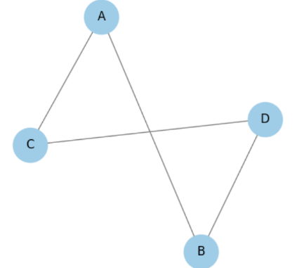
When to Use:
- Relationship Visualization: Helps show connections or interactions between entities.
- Community Detection: Useful to identify clusters or groups within a network.
- Path Analysis: Shows shortest or most efficient routes between nodes.

- Donut or Doughnut chart
When to Use:
- Show part-to-whole relationships like sales or market share.
- Track progress toward a goal (e.g., 70% completed).
- Best when comparing a few categories.

- Gauge Chart

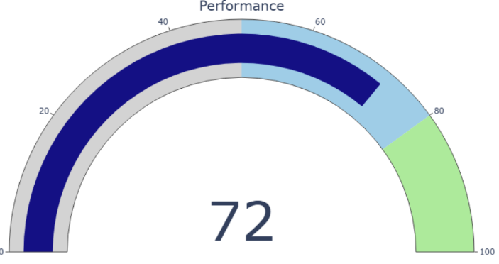
When to Use:
- To monitor key metrics (e.g., sales, satisfaction) toward targets
- In KPI dashboards to track progress
- For project status tracking against deadlines

- Sunburst Chart

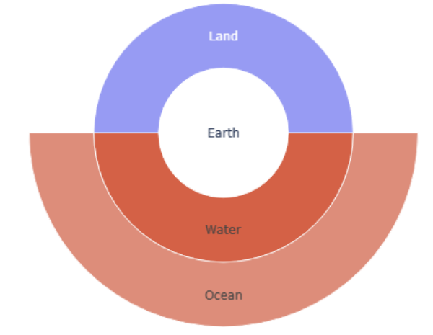
When to Use:
- To visualize hierarchical structures like org charts or file systems.
- To explore proportions and relationships within nested datasets.
- To simplify complex data in a clean, interactive layout.

- Hexbin Plot

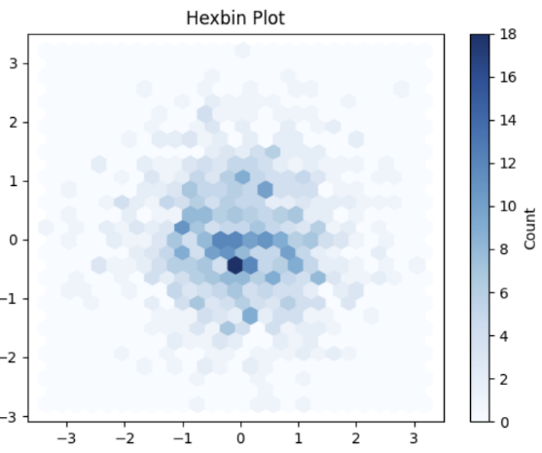
When to Use:
- To show data density in a 2D space.
- To spot clusters or patterns in large scatter data.
- To manage overlapping points in big datasets visually.

- Violin Plot
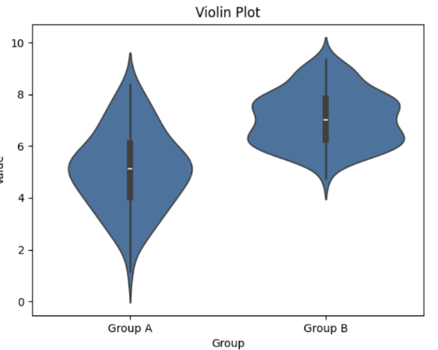
When to Use:
- Compare distribution of continuous data across groups.
- Visualize data shape, spread, skewness or multimodal patterns.
- Highlight detailed distribution and outliers in a clean layout.

Visualization Charts for Textual and Symbolic data
- Word Cloud
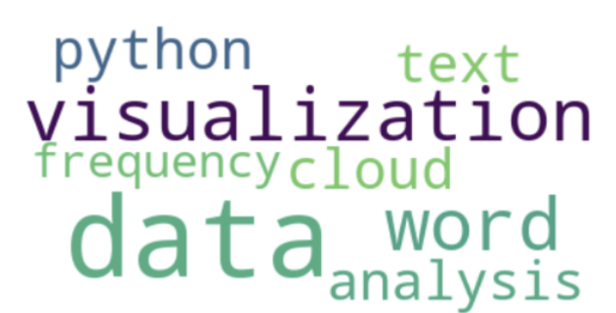
When to use:
- To highlight key themes or topics in large text data.
- To visualize word frequency in text analysis.
- To emphasize important terms in qualitative or sentiment analysis.

- Pictogram Chart

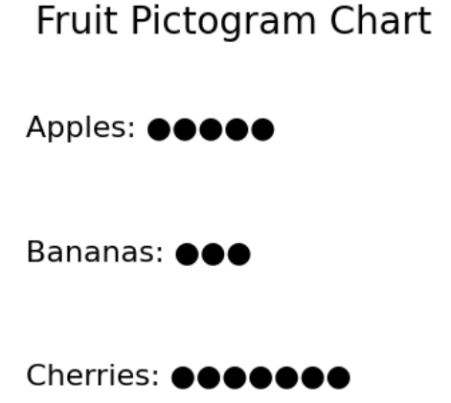
When to use:
- To present data using symbols, especially for non-numeric info.
- To communicate with audiences of all literacy levels.
- To highlight key trends using clear, recognizable icons.

Temporal and Trend Charts Data Visualization
- Streamgraph
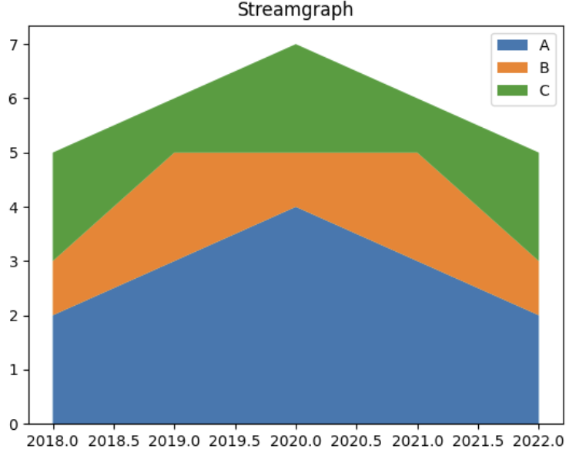
When to Use:
- To show trends and changes in category distribution over time
- To compare the size of different groups over time
- To highlight patterns in a smooth and visually appealing way
- Bullet Graph
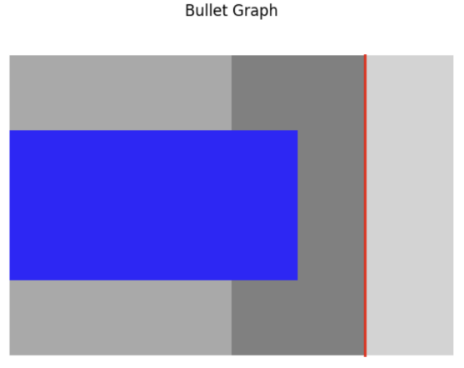
When to use:
- Show progress toward goals clearly and quickly.
- Compare actual performance with targets.
- Communicate key metrics in dashboards or reports.

- Gantt Chart
When to use:
- Plan and schedule tasks with dependencies.
- Track progress and resource use over time.
- Communicate timelines and milestones clearly.

- Waterfall Chart
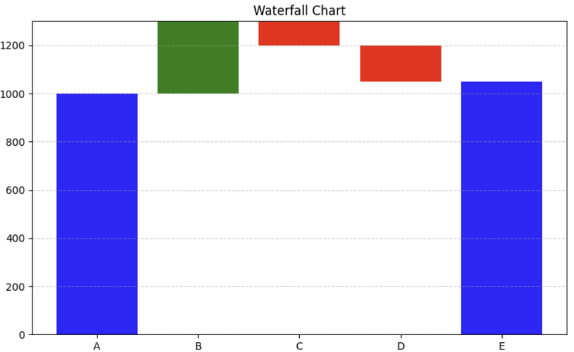
When to Use:
- Analyze step-by-step gains or losses over time.
- Understand the impact of different factors on totals.
- Present complex changes clearly and visually.

Steps to Handle Outliers
Situation | Action
Data Error | Remove
Valid but extreme | Cap
Skewed Data | Transform
Many Outliers | Robust Scaling
- Detect Outliers
  - Using IQR (most common)
Q1 = df['Age'].quantile(0.25)
Q3 = df['Age'].quantile(0.75)
IQR = Q3 - Q1

outliers = df[(df['Age'] < Q1 - 1.5*IQR) | (df['Age'] > Q3 + 1.5*IQR)]

  - Using Z-score
from scipy import stats
z_scores = stats.zscore(df['Salary'])
outliers = df[abs(z_scores) > 3]

- Decide What to Do
  - Remove outliers - Use when values are clearly wrong.
df = df[(df['Age'] >= Q1 - 1.5*IQR) & (df['Age'] <= Q3 + 1.5*IQR)]

  - Cap outliers (Winsorization) - Use when values are valid but extreme.
lower = Q1 - 1.5*IQR
upper = Q3 + 1.5*IQR
df['Age'] = df['Age'].clip(lower, upper)

  - Transform data - Use when data is skewed.
import numpy as np
df['Salary_log'] = np.log1p(df['Salary'])

  - Use Robust Scaling – Use when you don’t want to remove values.
from sklearn.preprocessing import RobustScaler
scaler = RobustScaler()
df[['Salary']] = scaler.fit_transform(df[['Salary']])

